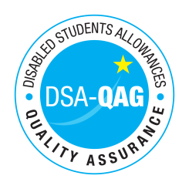
University Centre Reaseheath - NMH Rates

Period covered – 3/10/23 through to 1/1/24

The table below shows NMH rates. The greyed out cells indicate that the NMH provider does not offer these services.

Note: NMH Support Rates shown per hour in the table below.
 | Standard Rate (in-person) |  |  | Distance Learning only (in-person, in-home |  |  | Remote Delivery (e.g. Facetime/Skype or similar) Only
Band 4 Specialist Access and Learning Facilitators
Specialist Mentor – Mental Health | £51.00 | N/A | £51.00 |  |  |  | £51.00 | N/A | £51.00
Specialist Mentor – AS | £52.00 | N/A | £52.00 |  |  |  | £52.00 | N/A | £52.00
Specialist 1:1 Study Skills Support - SpLD | £52.00 | N/A | £52.00 |  |  |  | £52.00 | N/A | £52.00
Specialist 1:1 Study Skills Support - AS | £52.00 | N/A | £52.00 |  |  |  | £52.00 | N/A | £52.00

*Please delete any rows where you do not provide this support role

